Thank you for choosing to me help you to take a step towards finding out more about your nutritional status!

Completing a dietary record gives me a better idea of what you eat and drink on a regular basis and how we can work together to make changes. I understand that not every day or week will be the same, so this is a snapshot of your diet at this time. Feel free to be as honest and detailed as possible. This is a judgement-free zone!

If you forget to fill in a food, try to do so as soon as you remember.

# How to fill out the record:

* Please write everything you eat and drink from the time you wake until you go to sleep for the next 5 days.
* For each meal/snack start on a new row. See the example below
* Include the cooking methods. e.g. fried chicken, baked lamb, stewed beef.
* Include foods eaten away from home such as fast food or otherwise, even if you’re unsure of the cooking method.
* If the food item was low-fat, gluten-free, lactose-free, etc, include those details in their description. Inclusion of brand names of foods is also encouraged.
* If you don’t remember the time you ate something, that’s okay. An estimation is also useful.
* The use of household measures instead of actual weight or volume is also encouraged.

If you have any questions, feel free to email me at [info@nourishbych.com](mailto:info@nourishbych.com) . Here are a few examples below, so don’t worry, we got you!

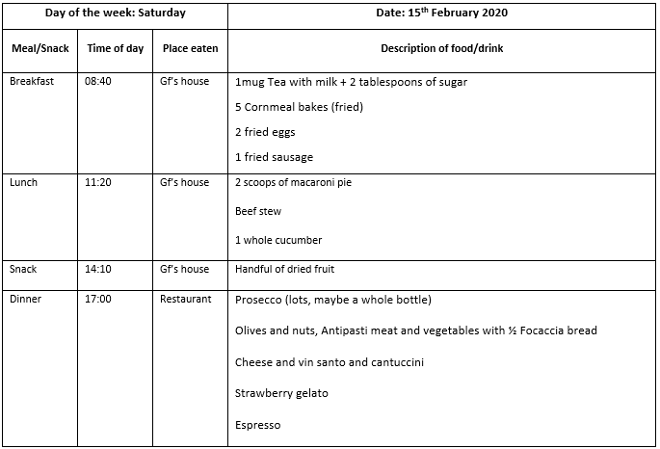

|  |  |  |  |  |
| --- | --- | --- | --- | --- |
| **Day of the week:** | | | **Date:** | |
| **Meal/Snack** | **Time of day** | **Place eaten** | **Description of food/drink** | **Mood** |
|  |  |  |  |  |
|  |  |  |  |  |
|  |  |  |  |  |
|  |  |  |  |  |
|  |  |  |  |  |
|  |  |  |  |  |

|  |  |  |  |  |
| --- | --- | --- | --- | --- |
| **Day of the week:** | | | **Date:** | |
| **Meal/Snack** | **Time of day** | **Place eaten** | **Description of food/drink** | **Mood** |
|  |  |  |  |  |
|  |  |  |  |  |
|  |  |  |  |  |
|  |  |  |  |  |
|  |  |  |  |  |
|  |  |  |  |  |

|  |  |  |  |  |
| --- | --- | --- | --- | --- |
| **Day of the week:** | | | **Date:** | |
| **Meal/Snack** | **Time of day** | **Place eaten** | **Description of food/drink** | **Mood** |
|  |  |  |  |  |
|  |  |  |  |  |
|  |  |  |  |  |
|  |  |  |  |  |
|  |  |  |  |  |
|  |  |  |  |  |

|  |  |  |  |  |
| --- | --- | --- | --- | --- |
| **Day of the week:** | | | **Date:** | |
| **Meal/Snack** | **Time of day** | **Place eaten** | **Description of food/drink** | **Mood** |
|  |  |  |  |  |
|  |  |  |  |  |
|  |  |  |  |  |
|  |  |  |  |  |
|  |  |  |  |  |
|  |  |  |  |  |

|  |  |  |  |  |
| --- | --- | --- | --- | --- |
| **Day of the week:** | | | **Date:** | |
| **Meal/Snack** | **Time of day** | **Place eaten** | **Description of food/drink** | **Mood** |
|  |  |  |  |  |
|  |  |  |  |  |
|  |  |  |  |  |
|  |  |  |  |  |
|  |  |  |  |  |
|  |  |  |  |  |